Faculty of Computing



**[CCN]**

**Lab No 7 Tasks**

**Task 1:**

Send a ping command for both HUB and SWITCH network using command prompt in packet tracer and notice the results in simulation mode.

**Scenario:**

Create simplest hub-based and switched-based networks, ideal for studying the different processes between hubs and switches. Add generic PCs and 2950-24 switches for one topology and generic hub with PCs the other topology.

Set the IP addresses ranging from 192.168.1.1 to 192.168.1.5 for one topology and 192.168.2.1 to 192.168.2.5 for another topology. All should have subnet masks 255.255.255.0.

**Reflect:**

Go to simulation mode. In event list filters, enable only ICMP and ARP. Using the “Simple PDU”, issue a ping from PC 0 to PC 1. Play the simulation. Pay close attention to how the hub processes the ICMP and ARP packets. After that, once again, use” Add simple PDU to issue a ping from PC1 to PC 0. Play the simulation again. How has the behavior of the hub changed from the first and second attempts, if at all?

Still in simulation mode, in the event List Filters, enable only ICMP and ARPO. Using the Add simple PDU issue a ping from PC 3 to PC 4. Play the simulation. Pay close attention to how the switch processes the ICMP and ARP packets. Now check for the behavior for the Switch.

***In what ways did the switch processes the packets similarly or differently from Hub between the first and second ping attempts?***

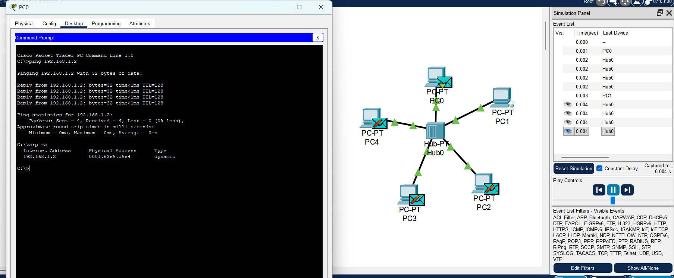

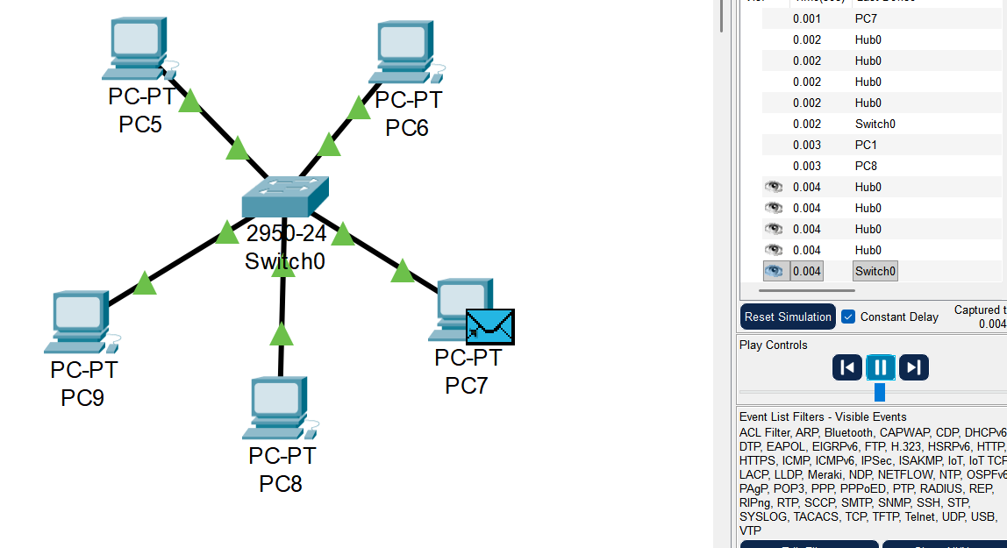

**Task 2:**

For the switched based network, set the new IP address and subnet mask for the PCs as follows.

|  |  |  |
| --- | --- | --- |
| **PC** | **IP ADDRESSES** | **SUBNET MASK** |
| PC0 | 192.168.1.36 | 255.255.255.224 |
| PC1 | 192.168.1.37 | 255.255.255.224 |
| PC2 | 192.168.1.38 | 255.255.255.224 |
| PC3 | 192.168.1.91 | 255.255.255.224 |

Tell about the communication. Communicated or not? If yes why.

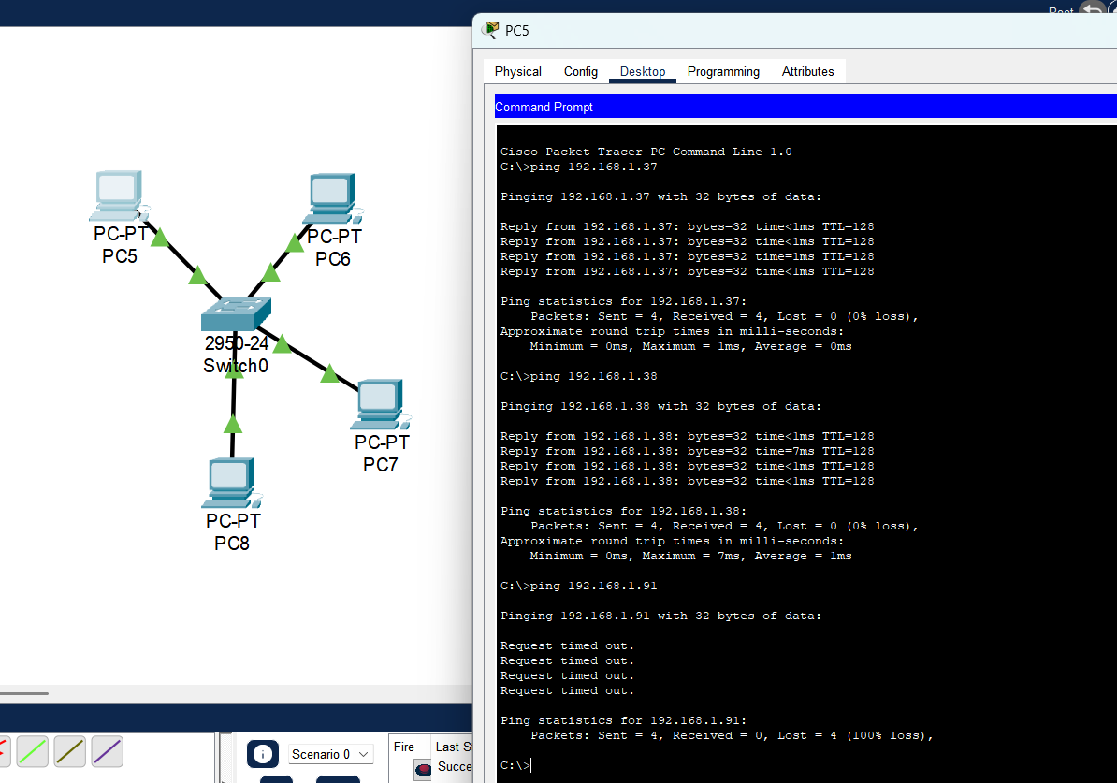

* PC3=PC8 di not communicated because subnet mask tells PC8 that 192.168.1.91 is not in its local network.

**Task 3:**

Create a star topology using a class A addressing scheme. Use Router to connect the end devices. Explain the behavior of the ping on each device. Use one router with 4 networks, 2 switches and 1 hub.

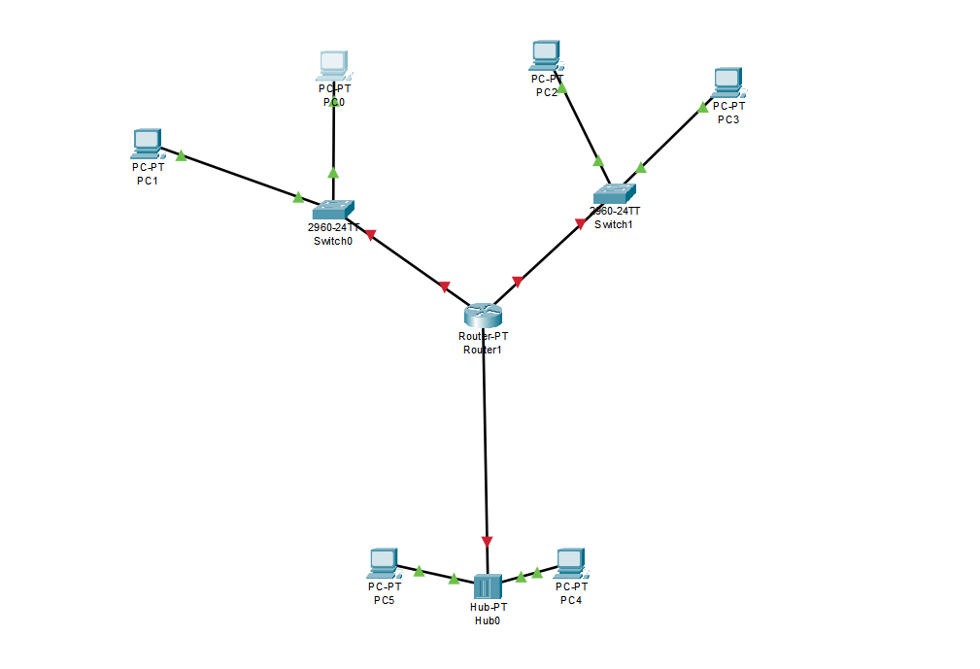

Create a **star topology** using one Cisco 2811 router, two 2960 switches, one generic hub, and six PCs. Connect Router **Fa0/0** to Switch0 (with PC0 and PC1), **Fa0/1** to Switch1 (with PC2 and PC3), and **Fa0/2** to the Hub (with PC4 and PC5). Assign IP addresses so that each network has its own subnet: Router interfaces (10.0.0.1, 10.0.1.1, 10.0.2.1), PCs with matching addresses (10.0.0.2/3, 10.0.1.2/3, 10.0.2.2/3), and set the router interface as the **default gateway** for each PC. When you test with **ping**, the first attempt may take time due to ARP, but subsequent pings will be quick. The router enables communication across all three networks, so every PC can successfully ping others, showing how the router routes packets between switch- and hub-connected devices.

**Answer:**

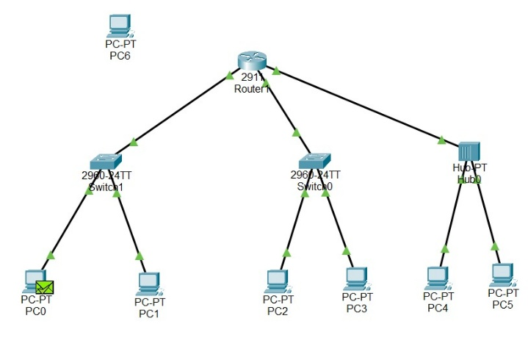

In **Task 3**, the router connects **four networks**:

1. **Switch1** – PC0 and PC1
2. **Switch0** – PC2 and PC3
3. **Hub** – PC4 and PC5
4. **Single PC6** directly connected to the router

This shows how a router interconnects multiple networks and forwards packets between them.

* The **router** connects **three switches**, each forming a separate network.
* **Switch0** has PC0 and PC1.
* **Switch1** has PC2 and PC3.
* **Switch2** has PC4 and PC5.

Here, PC0 is sending data. The router enables communication **between PCs in different switches/networks**.

• This shows how the router enables **inter-network communication** between PCs connected to different switches.

**Star Topology with Router, Switches, Hub, and PC**

**Router configured with 4 /24 networks:**

G0/0 = 10.0.1.1 → Switch1 (PC0, PC1)

G0/1 = 10.0.2.1 → Switch0 (PC2, PC3)

G0/2 = 10.0.3.1 → Hub (PC4, PC5)

Extra port = 10.0.4.1 → PC6

**Task 4:**

Create the topology shown in the below diagram

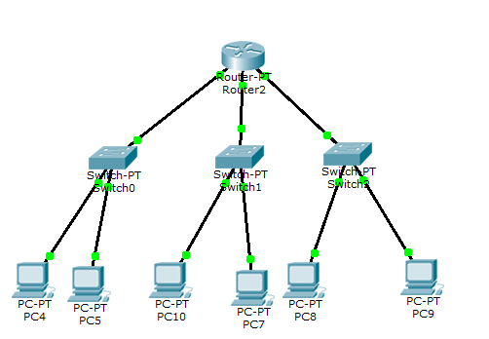

Send packets and ping commands and provide results with explanation.

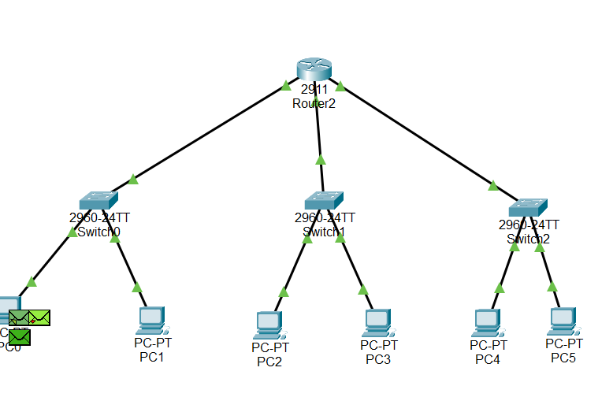

**Task 5:** What are ICMP and ARP in cisco packet tracer?

**ICMP (Internet Control Message Protocol):**  
It is used to send error messages and testing messages between devices. In Packet Tracer, ICMP is mainly seen when you use the **ping** command. For example, when one PC pings another, ICMP carries the “echo request” and “echo reply” messages.

**ARP (Address Resolution Protocol):**  
It is used to find the **MAC address** of a device when only its **IP address** is known. In Packet Tracer, when a PC wants to send data to another PC for the first time, it sends an ARP request asking “Who has this IP?” and the target replies with its MAC address. After that, communication can happen.